Question : 1
Generate 100 random numbers in Python that follow a normal distribution with mean 50 and standard deviation 10 using numpy, then plot the bell curve using matplotlib :

import numpy as np
import matplotlib.pyplot as plt
data =np.random.normal(50,10,100)
plt.hist(data,bins=10,density=True)
plt.title("Normal Distribution")
plt.xlabel("Values")
plt.ylabel("Frequency")
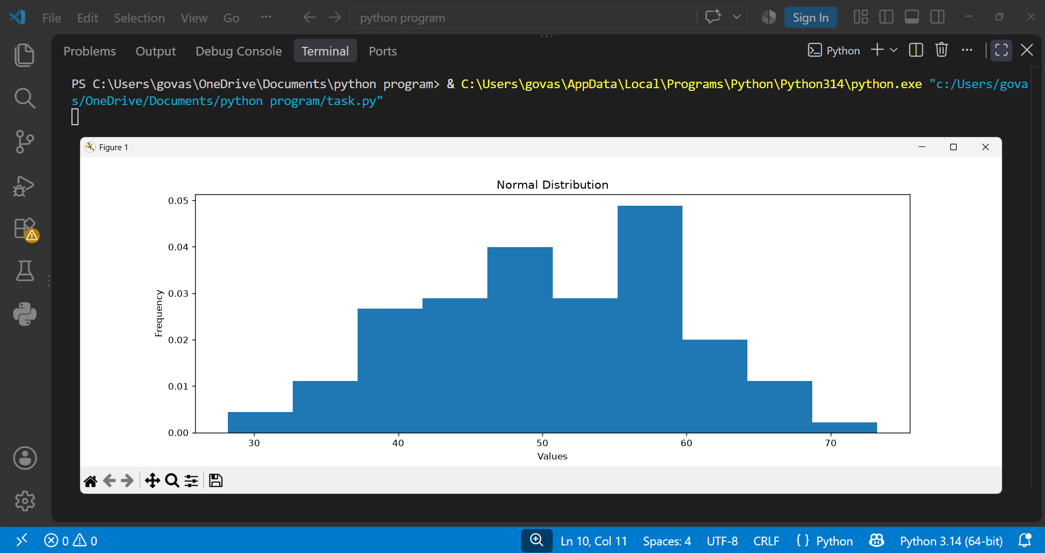
plt.show()
Question : 2
Given an array of 20 daily step counts from your fitness tracker app, calculate the mean, median, and mode, and check if they are approximately equal as expected in a normal distribution.<br><br><em><strong>Hint:</strong> Use numpy.mean(), numpy.median(), and scipy.stats.mode() : </em>

import numpy as np
from scipy import stats

steps = np.array([5000,5200,4800,5100,5000,5300,4900,5000,5200,5100,
5000,4800,5300,5000,5100,4900,5000,5200,5100,5000])

mean =np.mean(steps)
median =np.median(steps)
mode =stats.mode(steps,keepdims=True).mode[0]

print("Mean:",mean)
print("Median:",median)
print("Mode:",mode)
if abs(mean - median) < 200 and abs(median - mode) < 200:
print("Mean, median, and mode are approximately equal.")
else:
print("Mean, median, and mode are not approximately equal.")

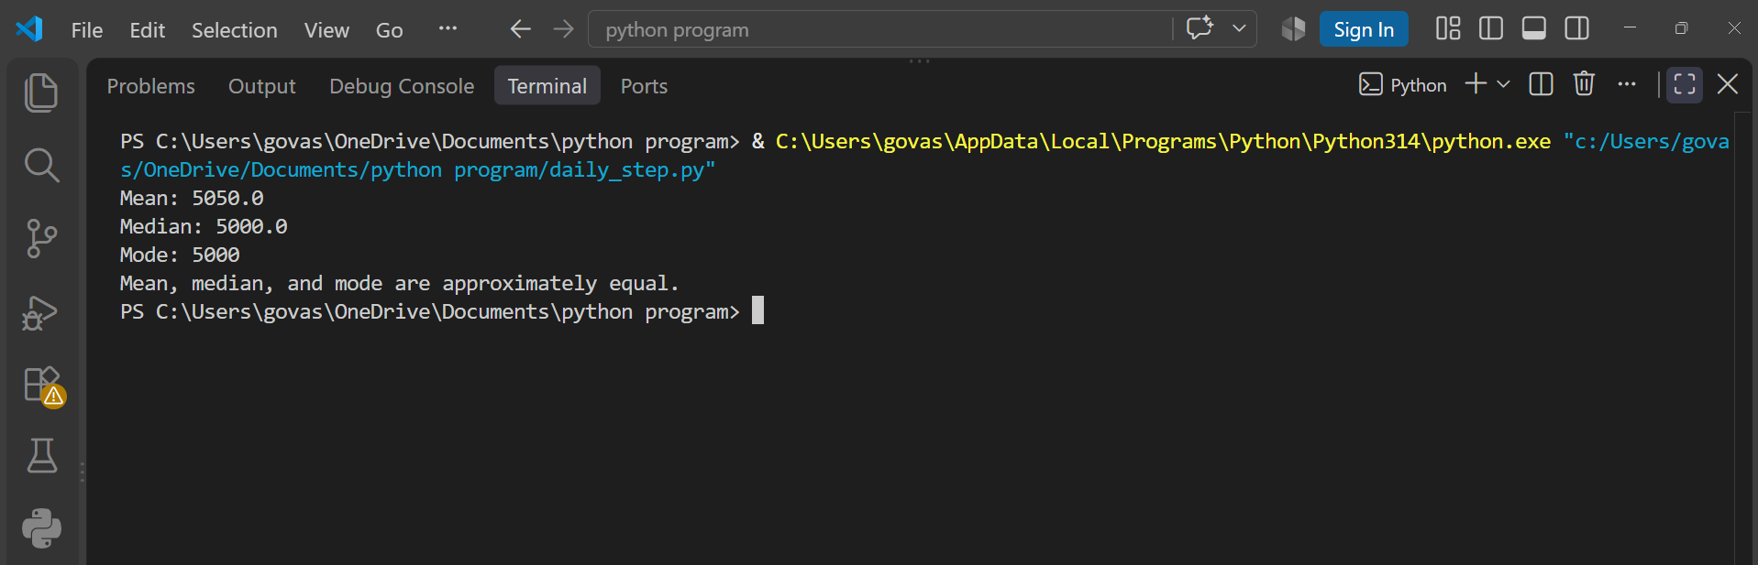
The mean, median, and mode are approximately equal, indicating that the step-count data is roughly symmetric and may follow a normal distribution.

Question : 3
Simulate the scores of 200 players in an online game (e.g., PUBG, Free Fire) using a normal distribution with mean 70 and standard deviation 15, then count how many players scored within one standard deviation (between 55 and 85) of the mean.<br><br><em><strong>Hint:</strong> Use the 68-95-99 rule to check your answer : </em>

import numpy as np
scores =np.random.normal(70,15,200)
count =np.sum((scores >= 55) & (scores <= 85))
print("Players scoring between 55 and 85:",count)
print("Expected players (68%):", round(200 * 0.68))

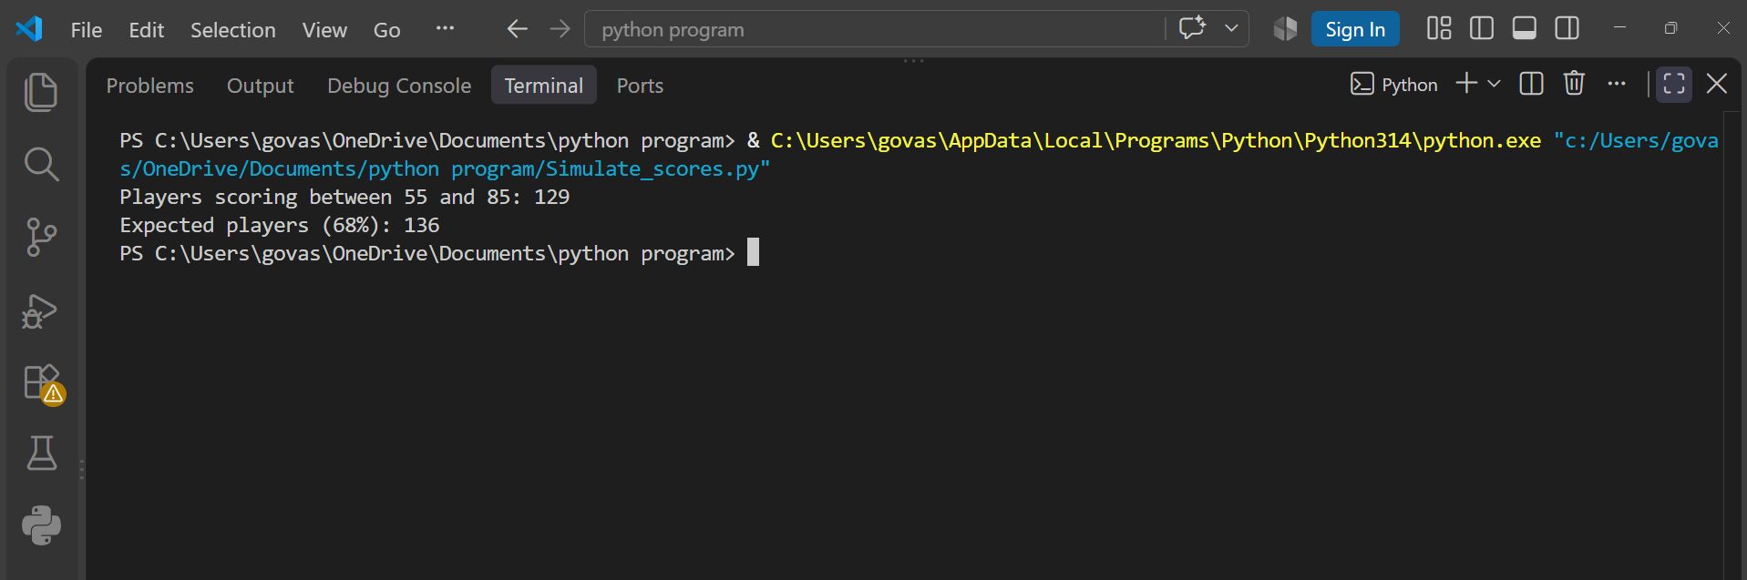
Around 68% of the players are expected to score within one standard deviation of the mean, so approximately 136 out of 200 players should score between 55 and 85.

Question : 4
Pick any real-world scenario (like delivery times for Zomato orders or playlist song durations on Spotify) and explain in 3-4 lines why the normal distribution might be a good fit for modeling this data :

Scenario: Zomato delivery times
Zomato delivery times can often be modeled using a normal distribution because most orders are delivered around an average time.
Some orders may take less or more time due to traffic, distance, or weather.
If these variations are fairly balanced around the average, a bell-shaped normal distribution can be a good model.

